Early Project Documentation: StudyTrack, a Personal Study Planner and Task Tracker
Draven Chen
Southern New Hampshire University
Software Engineering
August 6, 2026

Project Description
StudyTrack is a lightweight web application that helps college students organize coursework, plan study time, and monitor their own academic progress in one place. Students create tasks and study sessions tied to specific courses, receive reminders before deadlines, and view a personal dashboard summarizing completion rates and hours studied. The system is intentionally scoped to a single-user planning tool rather than a full learning management system, keeping the data model and feature set manageable for an initial release. A basic administrator role is included to manage the course list and user accounts, but the core value of the product is the student-facing planning and tracking experience.

Functional and Non-Functional Requirements

Functional Requirements
FR1: Task Creation and Management
Requirement statement: The system shall allow a student to create, edit, mark complete, and delete tasks, each with a title, description, due date, priority, and associated course.
Rationale: This requirement traces back to a Software Engineering course at Sampoerna University, where my coursemate and I built a Smart Parking System whose scope grew until we had to scale it down just to finish — a pattern of overrun that often starts with ambiguous, under-decomposed scope (Larson & Larson, 2009). Juggling that project with the rest of our coursework showed how quickly a task gets lost without a due date and a sense of priority. During brainstorming for that project we discussed ideas we’d want for ourselves, and a personal study tracker was one — the seed of StudyTrack.
FR2: Study Session Scheduling
Requirement statement: The system shall allow a student to schedule study sessions with a start time, end time, topic, and linked course, and to mark sessions as completed.
Rationale: During the Smart Parking project, my coursemate and I mostly planned our own work informally — sticky notes, phone reminders — and rarely tracked whether a planned session actually happened versus just intended. That gap is what this feature is meant to close: capturing scheduled sessions as first-class records lets the system later compute study-time analytics and forces the tool to reflect real behavior, not just intentions, which fits how requirements-engineering practice treats validating a system against actual, not assumed, user behavior (Burkin, 2023). This requirement also lays the groundwork for the progress dashboard.
FR3: Reminders and Notifications
Requirement statement: The system shall let a student set a reminder for a task or study session and shall notify the student at the configured trigger time.
Rationale: Deadline stress was the clearest lesson from the Smart Parking project: once we had to descope, the closer we got to the deadline, the more we relied on reminding each other manually instead of the system doing it for us. A proactive reminder is the fix for that gap. Tying reminders to existing tasks and sessions, rather than a separate free-standing notification system, keeps the data model simple while still meeting the underlying need: to be warned before it’s too late to act.
FR4: Progress Dashboard
Requirement statement: The system shall generate a dashboard showing the student's task completion rate and total study hours, filterable by course and date range.
Rationale: In my own experience, seeing progress — not just a running to-do list — is what keeps me motivated over a full semester; a completion percentage feels different from a stack of unchecked boxes. This requirement translates that into a concrete, testable feature and gives the project a natural home for future analytics work, without requiring changes to the underlying task and session data structures.

Non-Functional Requirements
NFR1: Performance and Responsiveness
Requirement statement: Core actions (creating a task, loading the dashboard, viewing a course's sessions) shall complete in under two seconds under normal load for a single user.
Rationale: I expect to open this app between classes or right before a deadline, so a slow interface would undermine the exact use case the tool is meant to support. A two-second budget is a reasonable early constraint for a single-user planning tool and gives me a concrete target to design and test against, rather than treating performance as an afterthought.
NFR2: Data Security and Privacy
Requirement statement: The system shall store passwords using a salted hash, transmit data over HTTPS, and restrict each student's data so it is visible only to that student and, where applicable, an administrator.
Rationale: Academic task and schedule data can reveal sensitive information about a student's workload and habits, and account credentials are an obvious attack target for any web-facing tool. This requirement reflects a standard engineering constraint — never store plaintext passwords, and scope data access to the owning account — the same baseline security practice requirements-engineering guidance treats as non-negotiable for any system handling personal data (Burkin, 2023).

UML Diagrams
The diagrams below model StudyTrack's primary actors and interactions (use case diagram) and its core data structure and responsibilities (class diagram). Both diagrams were derived directly from the functional requirements above: every functional requirement maps to at least one use case, and every noun in a requirement maps to a class or attribute.

Use Case Diagram
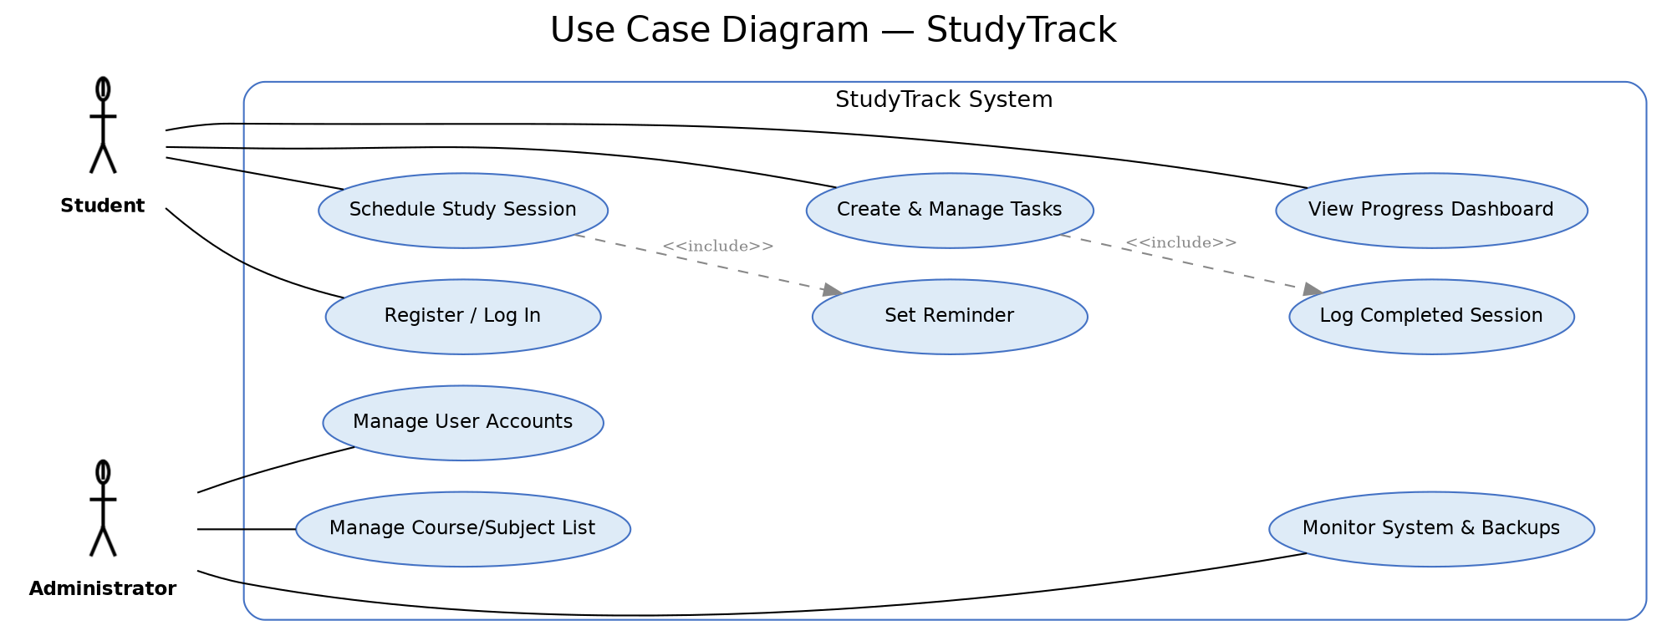
Figure 1. Use case diagram showing the Student and Administrator actors and their interactions with the StudyTrack system.

Class Diagram
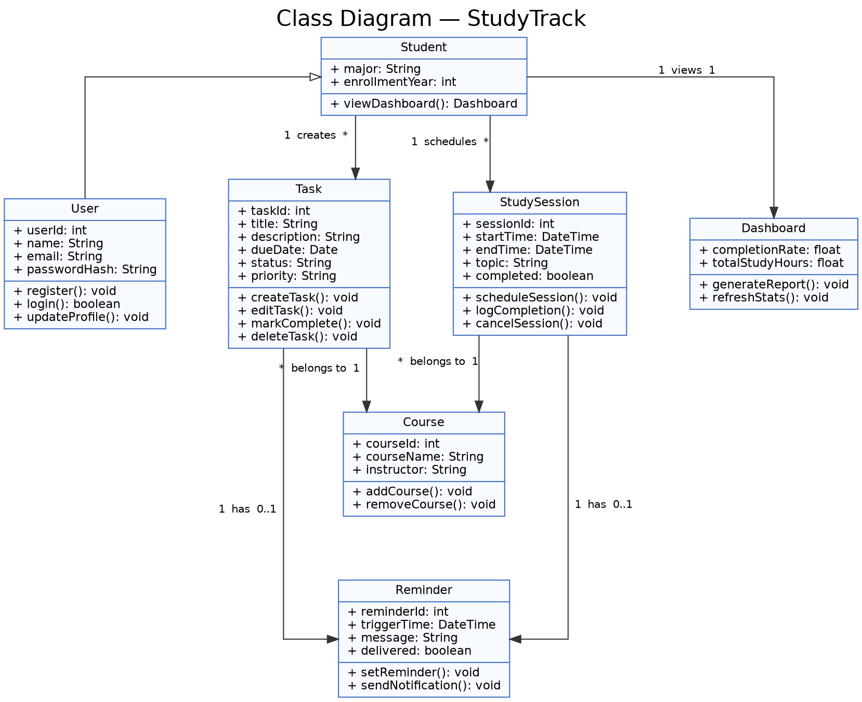
Figure 2. Class diagram showing StudyTrack's core classes, attributes, operations, and relationships.

Product Backlog
The user stories below translate the requirements into backlog items written from the student's point of view. Each includes acceptance criteria that will later support test-case design and sprint review.
US1: As a student, I want to create a task with a due date and priority, so that I can keep track of upcoming assignments in one place.
Acceptance Criteria:
- Given valid input, a new task is saved with title, due date, priority, and course.
- The task appears in the student's task list immediately after creation.
- Required fields (title, due date) cannot be left blank.
US2: As a student, I want to mark a task as complete, so that my dashboard accurately reflects my progress.
Acceptance Criteria:
- Marking a task complete updates its status and completion timestamp.
- Completed tasks are visually distinguished from open tasks in the task list.
- The dashboard's completion rate recalculates after the status change.
US3: As a student, I want to schedule a study session linked to a course, so that I can plan dedicated study time around my coursework.
Acceptance Criteria:
- A session requires a start time, end time, topic, and course.
- The system rejects a session whose end time is before its start time.
- Scheduled sessions appear in a calendar or list view sorted by date.
US4: As a student, I want to set a reminder for a task or session, so that I do not forget an approaching deadline or planned study block.
Acceptance Criteria:
- A reminder can be attached to any existing task or session.
- The student receives a notification at the configured trigger time.
- A delivered reminder is marked as sent and is not re-sent.
US5: As a student, I want to view a dashboard of my completion rate and study hours, so that I can gauge whether I am keeping up with my workload.
Acceptance Criteria:
- The dashboard displays completion rate and total study hours.
- Results can be filtered by course and by date range.
- The dashboard reflects data updates within the same session (no manual refresh required).
US6: As an administrator, I want to manage the course list, so that students always choose from an accurate set of active courses.
Acceptance Criteria:
- An administrator can add, edit, and deactivate a course.
- Deactivated courses no longer appear as options for new tasks or sessions.
- Existing tasks/sessions linked to a deactivated course remain visible for the student.

Sprint Planning Documentation
Sprint 1 focuses on the smallest set of stories that produces a usable, testable slice of the product: creating tasks, completing tasks, and viewing the resulting progress on a dashboard. Scheduling, reminders, and course administration are deferred to later sprints once this core loop is validated.
User Story | Task | Estimated Effort | Timeline | Tools / Resources
US1 | Design Task data model and database schema | 3 hrs | Day 1 | Draw.io, SQLite
US1 | Build task creation form and validation | 5 hrs | Days 1–2 | React, VS Code
US1 | Implement save-task API endpoint | 4 hrs | Day 2 | Node.js, Express
US2 | Add complete/incomplete toggle to task list UI | 3 hrs | Day 3 | React
US2 | Implement status-update API endpoint | 3 hrs | Day 3 | Node.js, Express
US5 | Build dashboard query for completion rate | 4 hrs | Day 4 | SQL, Node.js
US5 | Build dashboard UI (completion rate view) | 5 hrs | Days 4–5 | React, Chart library
US1/US2/US5 | Manual test pass and bug fixes | 4 hrs | Day 5 | Browser dev tools, test checklist

This sprint structure follows the Agile/Scrum model, using short, fixed-length iterations that each deliver a working, demonstrable increment of the product. Scrum was chosen over a plan-driven model such as Waterfall partly because of what happened with Smart Parking: locking in a full scope up front and only discovering it didn’t fit the timeline near the end is exactly the failure mode I want to avoid here, and it matches a well-documented driver of project overrun — ambiguous scope combined with a long, undivided project length (Larson & Larson, 2009). Scrum's short feedback cycle instead lets me validate assumptions (for example, whether the dashboard's completion-rate calculation is actually meaningful to students) after one week rather than after the entire system is built. A one-week, single-developer sprint also matches the manageable scope of this project: it is long enough to complete a vertical slice of functionality (data model through UI) but short enough to re-plan quickly if a task takes longer than estimated.

Reflection
Working through requirements before writing any code clarified something I did not fully absorb during the Smart Parking project at Sampoerna: writing a rationale forces a concrete answer to who needs this and why. Smart Parking’s scope grew because we never had to answer that question early enough, and by the time we scaled the project down, a couple of features we had designed around did not have a clear justification (Larson & Larson, 2009). Writing a rationale for each StudyTrack requirement caught something similar: an early idea for social/leaderboard features had no real justification and was dropped before it reached the backlog. Building the use case and class diagrams side by side also surfaced a design question I had not considered — whether a reminder belongs to a task/session or exists independently. What I have not resolved yet is backend integration: how the task, session, and reminder data will actually persist and sync, and how much time to spend polishing that layer versus shipping sooner. Given how Smart Parking’s scope crept the longer we sat with it, I would rather ship something small and real than keep refining a plan.

References
Burkin, V. (2023). Mitigating risks in software development through effective requirements engineering. University of Illinois Urbana-Champaign. https://arxiv.org/abs/2305.05800
Larson, R., & Larson, E. (2009). Top five causes of scope creep… and what to do about them. Project Management Institute. https://www.pmi.org/learning/library/top-five-causes-scope-creep-6675

